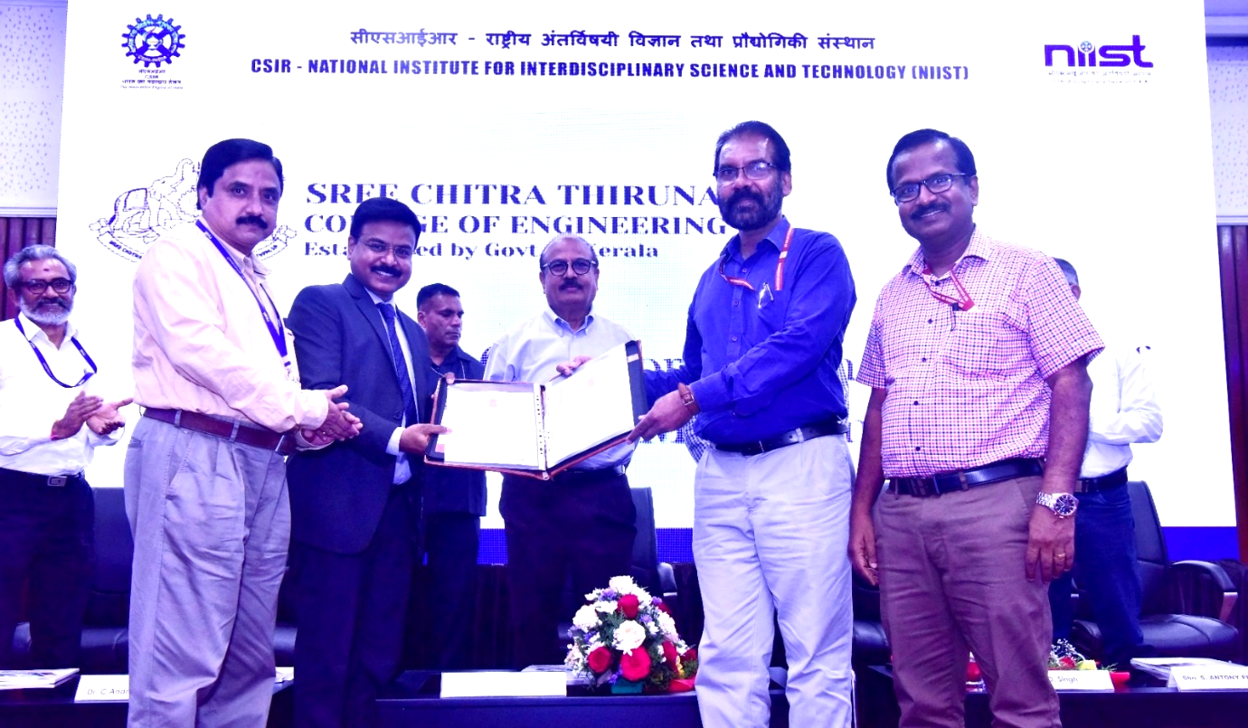

* Academic collaboration which includes combined projects, internship, visits, etc.

**MoU with CSIR-NIIST**